Lab 1 (2%)

Join, group by, having, views.

topics

join, group by, having, views

Group work acknowledgment

We members of Group 2 **[Kabir Narula] [Maksym Volkovynskyi**] declare that the attached assignment is our own work in accordance with the Seneca Academic Policy. No part of this assignment has been copied manually or electronically from any other source (including web sites) **or distributed to other students.**

**Specify below what each member has done towards the completion of this work:**

|  |  |  |
| --- | --- | --- |
|  | **Name** | **Task(s)** |
| **1-** | **Kabir Narula** | **Everything** |
| **2-** | **Maksym Volkovynskyi** | **Everything** |

**We did each question individually so that we can practice better and then later compared and matched our answers…**

Before you start

You are to create a new database named “AviaCo” and run the sql script you are given to create the tables in the database.

Instructions

For each of the following questions write the sql query (in text) and show the result set underneath each SQL query.

1. Show all charter trip codes and their crews (show the crew employee number, first and last name and the crew job).

Order the rows by charter trip number.

Output: first 5 rows out of 24 rows

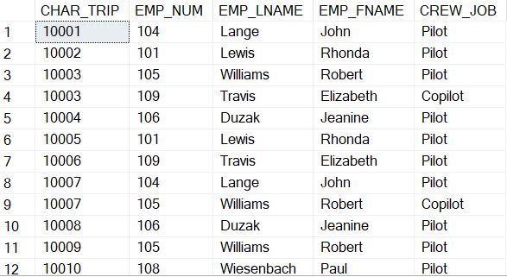

**[Answer] ----------**

SELECT TOP 5 CHARTER.CHAR_TRIP, CREW.EMP_NUM, EMPLOYEE.EMP_LNAME, EMPLOYEE.EMP_FNAME, CREW.CREW_JOB

FROM CHARTER

INNER JOIN CREW ON CHARTER.CHAR_TRIP = CREW.CHAR_TRIP

INNER JOIN EMPLOYEE ON CREW.EMP_NUM = EMPLOYEE.EMP_NUM

ORDER BY CHARTER.CHAR_TRIP;

**[Output] ----------**

1. Show all charter trip code, date, destination, distance and hours flown and charter crews (show the crew employee number, first and last name and the crew job).

Order the rows by charter trip number.

Format the charter dates based on format code 1 (MM/DD/YY)

Output: first 5 rows out of 24 rows

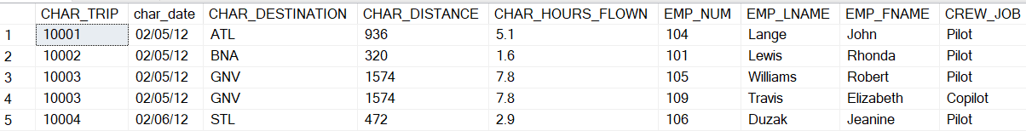

**[Answer] ----------**

SELECT CHARTER.CHAR_TRIP, FORMAT (CHAR_DATE, 'MM/dd/yy') AS CHAR_DATE, CHAR_DESTINATION, CHAR_DISTANCE, CHAR_HOURS_FLOWN, CREW.EMP_NUM, EMPLOYEE.EMP_LNAME, EMPLOYEE.EMP_FNAME, CREW.CREW_JOB

FROM CHARTER

INNER JOIN CREW ON CHARTER.CHAR_TRIP = CREW.CHAR_TRIP

INNER JOIN EMPLOYEE ON CREW.EMP_NUM = EMPLOYEE.EMP_NUM

ORDER BY CHARTER.CHAR_TRIP;

**[Output] ---------**

1. Show all customers (the customer code, first and last name) and their booked charter trips (show the charter codes, date, destination, distance, hours flown) and charter crews (show the crew employee number, first and last name and the crew job).

Output: first 5 rows out of 24 rows



**[Answer] ----------**

select TOP 5 c3.CUS_CODE, c3.CUS_FNAME, c3.CUS_LNAME, c.CHAR_TRIP, FORMAT (CHAR_DATE, 'MM/dd/yy') AS CHAR_DATE, c.CHAR_DESTINATION, c.CHAR_DISTANCE, c.CHAR_HOURS_FLOWN ,c2.EMP_NUM, e.EMP_LNAME, e.EMP_FNAME, c2.CREW_JOB

from CHARTER c

join CREW c2 on c.CHAR_TRIP = c2.CHAR_TRIP

join EMPLOYEE e on e.EMP_NUM = c2.EMP_NUM

join CUSTOMER c3 on c.CUS_CODE = c3.CUS_CODE

order by c3.CUS_CODE

**[Output] ----------**

1. Show all aircraft model codes and the number of aircrafts associated with each.

Output:

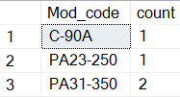

**[Answer] ----------**

SELECT MOD_CODE, COUNT(*) AS AircraftCount

FROM AIRCRAFT

GROUP BY MOD_CODE;

**[Output] ----------**

1. show the customers and the number of charters they have booked. Show the customer code, last and first name (all concatenated) and the number of associated charters.

Output:

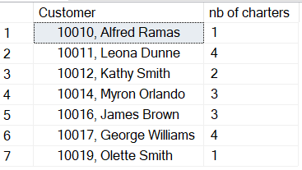

**[Answer] ----------**

SELECT CUSTOMER.CUS_CODE, CONCAT(CUSTOMER.CUS_FNAME, ', ', CUSTOMER.CUS_LNAME) AS CustomerName, COUNT(*) AS CharterCount

FROM CUSTOMER

INNER JOIN CHARTER ON CUSTOMER.CUS_CODE = CHARTER.CUS_CODE

GROUP BY CUSTOMER.CUS_CODE, CUSTOMER.CUS_LNAME, CUSTOMER.CUS_FNAME;

**[Output] ----------**

1. show the crew and the number of charters they were on. Result set should include emp_num, emp_fname, emp_lname, and number of charters.

Output:

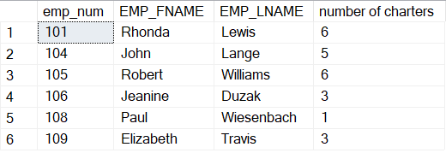

**[Answer] ----------**

SELECT CREW.EMP_NUM, EMPLOYEE.EMP_FNAME, EMPLOYEE.EMP_LNAME, COUNT(*) AS CharterCount

FROM CREW

INNER JOIN EMPLOYEE ON CREW.EMP_NUM = EMPLOYEE.EMP_NUM

GROUP BY CREW.EMP_NUM, EMPLOYEE.EMP_FNAME, EMPLOYEE.EMP_LNAME;

**[Output] ----------**

1. Extract the first two characters of the model code and count the number of aircrafts for each.

Output:

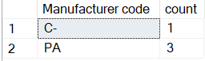

**[Answer] ----------**

SELECT LEFT(MOD_CODE, 2) AS ModelPrefix, COUNT(*) AS AircraftCount

FROM AIRCRAFT

GROUP BY LEFT(MOD_CODE, 2);

**[Output] ----------**

1. Show all charter trip codes, the charter distance and whether the distance is less than 1000 miles or larger than 1000 miles.

use IIF function, <https://www.w3schools.com/sql/func_sqlserver_iif.asp>

Output: first 5 out of 18

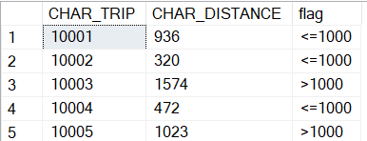

**[Answer] ----------**

select c.CHAR_TRIP, c.CHAR_DISTANCE, IIF(c.CHAR_DISTANCE <= 1000, '<=1000', '>1000') as flag

from CHARTER c

**[Output] ----------**

1. Count the number of charters whose distance is less than 1000 and those that have a distance larger than 1000. Then calculate the proportions of the charters in each bin.

-- cast the count as float so you get the ratio instead of 0.

use IIF function, <https://www.w3schools.com/sql/func_sqlserver_iif.asp>

Output:

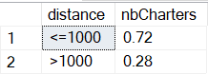

**[Answer] ----------**

select '<=1000' as distance,

CAST((select COUNT(*) from CHARTER c2 where c2.CHAR_DISTANCE <=1000) / CAST(COUNT(*) as FLOAT) as DECIMAL(18,2)) as nbCharters

from CHARTER c

UNION ALL

select '>1000' as distance,

CAST((select COUNT(*) from CHARTER c2 where c2.CHAR_DISTANCE >1000) / CAST(COUNT(*) as FLOAT) as DECIMAL(18,2)) as nbCharters

from CHARTER c

**[Output] ----------**

1. show the total fuel consumption, the total distance traveled, and the total hours flown per aircraft for aircrafts whose total hours flown is more than 15 hours.

Output:

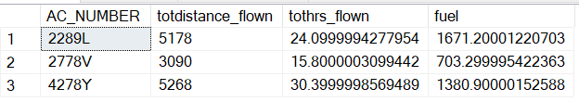

**[Answer] ----------**

select c.AC_NUMBER,

cast(sum(c.CHAR_DISTANCE) as DECIMAL(18,0)) as totdistance_flown,

sum(c.CHAR_HOURS_FLOWN) as tothrs_flown,

sum(c.CHAR_FUEL_GALLONS) as fuel

from CHARTER c

group by c.AC_NUMBER

having sum(c.CHAR_HOURS_FLOWN) > 15

**[Output] ----------**

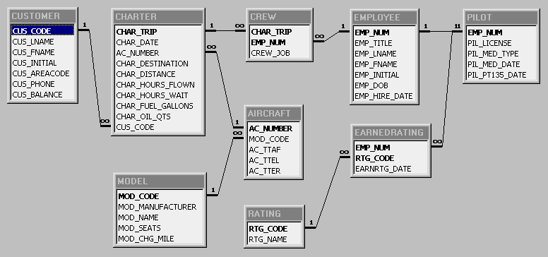

Figure : The AviaCo_2-Relational Diagram

SUBMISSION

Submit your lab1_GroupX.doc file on BB. Replace X with your group number.

If a student does not contribute to the work, do not list his/her name(s) under the group section in the lab file and will get 0.

Grading rubrics

Each question is worth 5pts. Total is 50 pts.

If the output is included without the query, the answer is worth 0.